Title of One-Page Abstract for A-COE 2026 (Times New Roman 14, Bold)

1stAuthor^{a,#}, 2ndAuthor^{b}, 3rdAuthor^{b,*}
ªFull address of first author, including country.
^{b}List all distinct addresses in the same way.
Corresponding author. Email: acoe2024@omu.ac.jp
# Presenting Author and *Corresponding Author

Keywords: 5 keywords maximum related to your abstract.

Please follow this template when preparing your abstract for A-COE 2024. The abstract should contain less than 500 words and should fit in one page including any Figures and References needed. If possible, use MS Word to this template, which uses A4 paper with 0.75” left and right margins, and 1” top and bottom margins.

Kindly, use Times New Roman font size 11 with single line spacing and first line indentation by 0.3”. Text alignment should be justified.
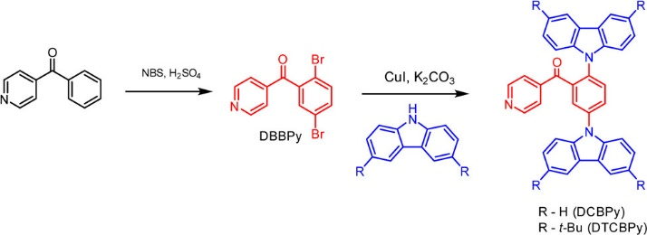

Fig. 1. Synthesis of DCBPy and DTCBPy (font size 10).

[References] Write reference numbers in the text as superscript¹. Place the references (font size 10) at the end of the document. Do not write the word “references”, and insert a blank line before the first reference.
(1) Kiet Tuong Ly, Ren-Wu Chen-Cheng, Hao-Wu Lin, Yu-Jeng Shiau, Shih-Hung Liu, Pi-Tai Chou, Cheng-Si Tsao, Yu-Ching Huang, Yun Chi, Nat. Photonics, 2017, 11, 63.
(2) Tien-Lin Wu, Min-Jie Huang, Chih-Chun Lin, Pei-Yun Huang, Tsu-Yu Chou, Ren-Wu Chen-Cheng, Hao-Wu Lin, Rai-Shung Liu, Chien-Hong Cheng, Nat. Photonics, 2018, 12, 235.

